* **Generate a Sequence of Blinking LEDs using PIC microcontroller** Click on **Project >> New Project**



* Click **Next**

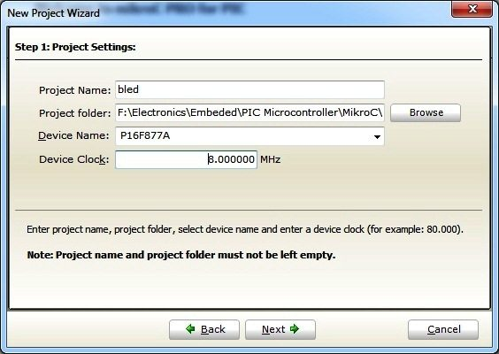

* Enter Project name, path (created folder path), clock frequency, microcontroller and click **Next**. Clock Frequency is the frequency of oscillator used with microcontroller. Here we use PIC 16F877A microcontroller with 8MHz crystal.

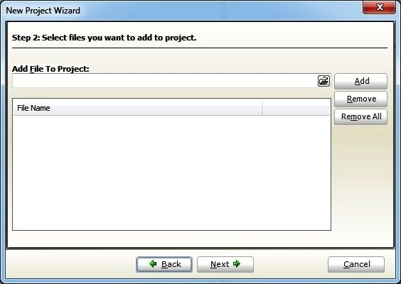

* Here you can add your subprogram files or user defined header files in large projects. Hence we are dealing with simple LED Blinking in this tutorial, ignore it and click **Next**.

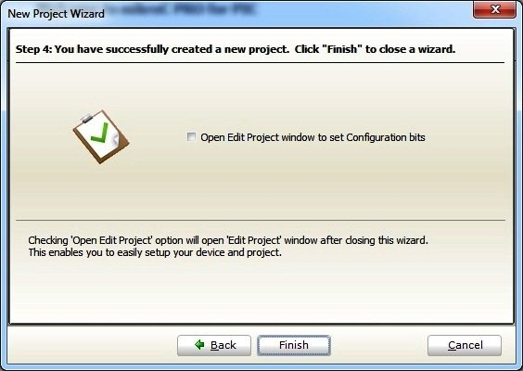

* Click **Finish**, to complete the New Project Wizard.
* Then you will see the editor, where you can enter the MikroC Code.

**Exercise – Task**

If the pushbutton on RB1 is pressed the LED blinking sequence would be initiated.

**Pull-up resistors on PORTB**

Configure **OPTION** register to enable pull up resistors on port B





**RBPU – Port B Pull up Enable bit**

1- Porta B pull-ups are disabled

0 – Porta B pull-ups are enabled

Three different ways to enable Pull-up resistors:

OPTION.F7 =0; // set individual bit RPBU

OPTION_REG= 0b00000000; // set OPTION_REG as byte binary

OPTION_REG= 0x00; // set OPTION_REG as byte in hex form

TRISB register

**MikroC Code – Blinking an LED**

The following program blinks an LED with a delay of 1 second.

void main()

{

TRISB.F0 = 0; //Makes PORTB0 or RB0 Output Pin

while(1) //Infinite Loop

{

PORTB.F0 = 1; //LED ON

Delay_ms(1000); //1 Second Delay

PORTB.F0 = 0; //LED OFF

Delay_ms(1000); //1 Second Delay

}

}

* Enter the above MikroC code

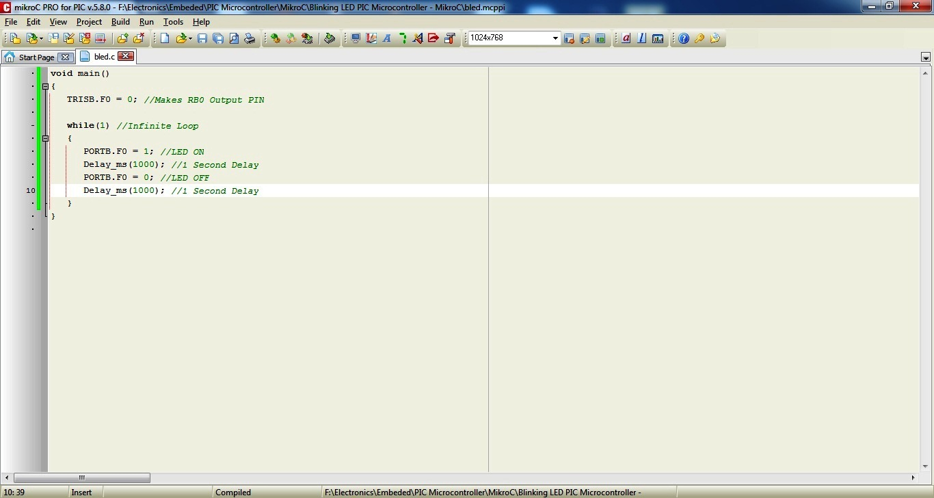

Save it

Then Compile it. Click Build >> Build (or Ctrl+F9)

A hex file will be generated in your Project Folder. You need to write this file to microcontroller using a programmer.

